Vectors and Matrices and R

We’re going to spend a little time studying vectors and matrices, and how to work with them in R. Vectors and matrices may be a new topic for some of you. If it is, here is a brief introduction, together with some R code.

You should add to your portfolio an annotated .R file, called matrix.R, containing all your R commands with suitable comment lines.

Vector and Matrix Fundamentals

Let 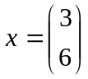 and 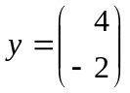; these are examples of vectors.

We can add vectors:

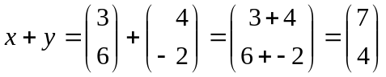.

We can subtract vectors:

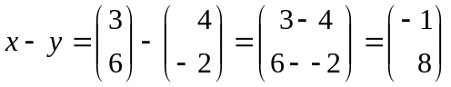.

We can multiply vectors by a number:

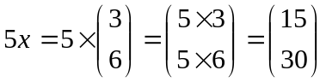.

Let 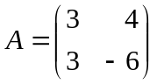; this is a matrix. It has two rows and two columns and is referred to as a 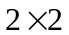 matrix. Let 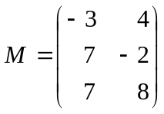; 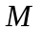 is a 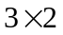 matrix as it has three rows and two columns.

Remember that we took . The transpose of , denoted 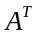, is found by swapping the rows with the columns:

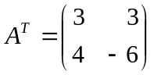.

Let 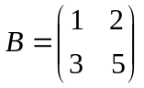. We can multiply two matrices:

The identity matrix is defined as

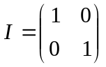.

Note that

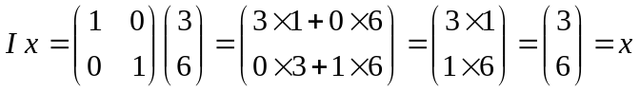,

so multiplying by has no effect.

Exercise: Show that 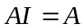 and 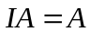.

Remember that we took . The inverse of , denoted 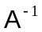, is found as follows:

- Calculate the determinant. This is done by multiplying the diagonal elements and subtracting the product of the other two elements:

.

- Swap the elements on the diagonal:

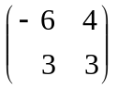.

- Multiply the other elements by 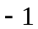:

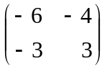.

- Divide by the determinant:

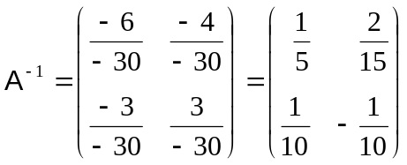.

Note that we can divide by the determinant since it is 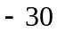. If the determinant were zero, we couldn’t divide by it! In that case we would say that the matrix is non-invertible or singular.

Exercise: Confirm that 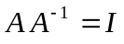 and 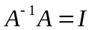.

Implementation in R

Here is the R code to do the above. Try it. Make sure that you understand every line.

# Define x; the function c collects together the elements
# of the vector
#
x <- c(3,6)
#
# Look at it
#
x
#
# It's printed as a column to save space; it's thought of as a row vector
#
# Now y
#
y <- c(4,-2)
#
# Add
#
x + y
#
# Subtract
#
x - y
#
#
# Multiply by a constant
#
5*x
#
# Define the matrix A
#
A <- matrix(c(3,4,3,-6), nrow = 2, byrow = T)
A
#
# Define the matrix M
#
M <- matrix(c(-3,4,7,-2,7,8), nrow = 3, byrow = T)
M
#
# The transpose of A
#
t(A)
#
# Define the matrix B
#
B <- matrix(c(1,2,3,5), nrow = 2, byrow = T)
B
#
# Multiply A by B; %*% is used for matrix multiplication
#
A %*% B
#
# The 2 by 2 identity matrix
#
I <- diag(2)
#
# Calculate I x
#
I %*% x
#
# Compare with x
#
x
#
# A I and I A
#
A %*% I
A
I %*% A
A
#
# Determinant
#
det(A)
#
# Inverse of A, using the function solve
#
A.inv <- solve(A)
A.inv
#
# Confirm
#
A %*% A.inv
A.inv %*% A

Simultaneous Equations

Let’s look at the solution of simultaneous equations using matrices.

Exercise:

Solve

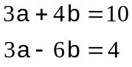

for and directly.

These two equations represent two lines.

Exercise: Plot these lines on a graph. Hint: It’s necessary to set up a blank plotting area first. Here’s the code for that:

plot(10/4, -4/6, type = "n",
xlim = c(-2,6), ylim = c(-2,4), xlab = "a", ylab = "b")

The argument type = "n" means no plotting!

Now you plot the lines. Here’s my graph; you can see what the solution is!

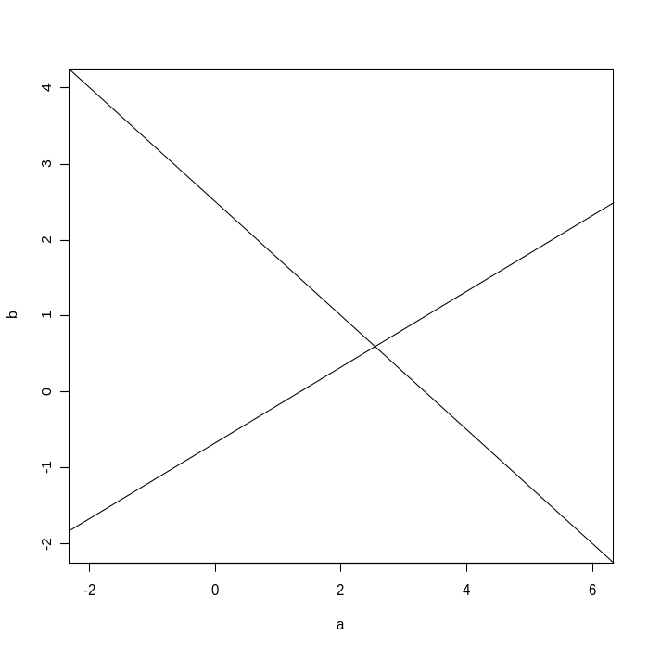

We can represent the above equations

in matrix form as

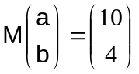,

where 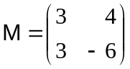. This matrix equation can be solved by multiplying by 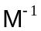the inverse of :

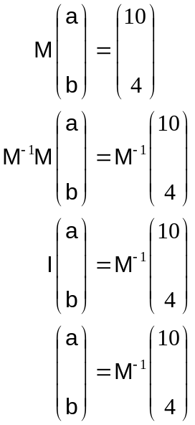

Exercise: Find by hand and hence confirm the solution for 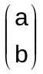 that you found above.

You can check your results in R:

# Define M
#
M <- matrix(c(3,4,3,-6), nrow = 2, byrow = T)

Exercise: Calculate the determinant of in R in two ways and hence confirm that the matrix is invertible.

R code continues

Now find 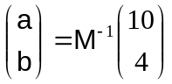, remembering that the function solve provides the inverse of a matrix:

ab <- solve(M) %*% c(10,4)
ab
#
# Check that ab satisfies the original equations
# by substituting; the answer should be c(10,4)
#
M %*% ab
#
# As a shorter alternative try
#
solve(M , c(10,4))

Exercise: Plot the solution on your graph and add appropriate horizontal and vertical lines
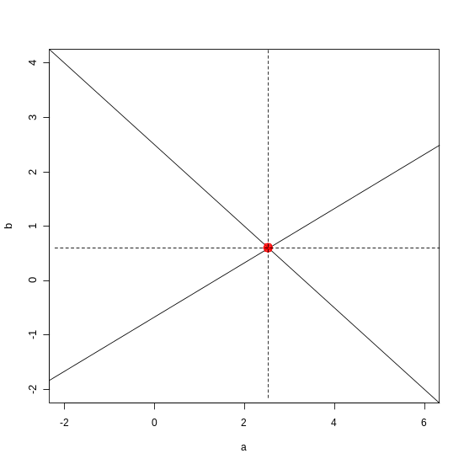

Matrices and Data

We’re going to carry on our study of matrices using some data to motivate what we are doing.

Data

Six children are selected at random from a junior school. Here are their ages in months and heights in cm:

Age (months) | 53 | 43 | 58 | 38 | 49 | 55
Height (cm) | 98 | 91 | 104 | 89 | 97 | 99

The first step when analyzing this data set, as with any data set, is to input the data into R and to plot them.

As we are mathematicians/statisticians, we don’t mind referring to values of age using the vector and to values of height as . We refer to the th data pair as 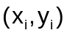. We also refer to the total number of data points as . Here 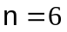.

Inputting the Data

To input data, do

x <- c(53, 43, 58, 38, 49, 55)
x
y <- c(98, 91, 104, 89, 97, 99)
y

Plotting the Data

Exercise: Reproduce, or improve on, this graph:

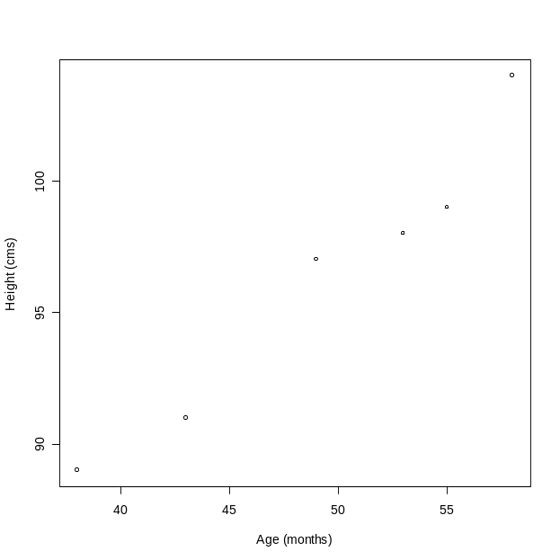

The data seem to support an underlying linear relationship.

The Data Matrix

We are going to estimate the underlying linear relationship by using matrix calculations. First, let’s create a matrix 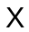 containing the data:

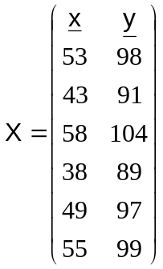
In R

#
# Bind together the x and y data columns into a matrix X
#
X <- cbind(x,y)
X
Elements of can be accessed using obvious notation. Make sure that you understand these:

X[4,1]
X[6,2]
X[1,]
X[4,]
X[,1]
X[,2]
X[2:6,1]
X[2:6,]
X[2:6,1:2]

Covariance Matrix

We are now going to work out the sample covariance matrix as defined and discussed in lectures. For this we need to create a centred matrix 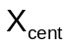 by subtracting the column means:

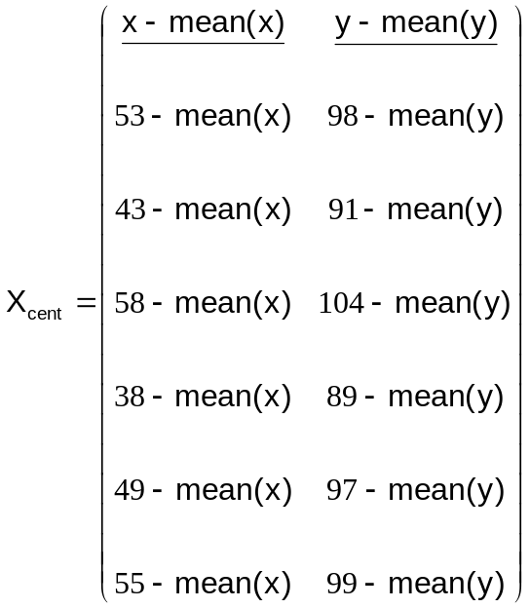

We’ve seen that the columns of this centred matrix have mean zero. Let’s calculate in R:

#
# Centre each column by subtracting the means
#
X.cent <- cbind(x - mean(x) , y - mean(y))
#
# Check the column means
#
colMeans(X.cent)
#
# Calculate in another way;
# here, 2 indicates that the function mean should be
# applied to the columns of X.cent
# [use 1 for rows]
#
apply(X.cent, 2, mean)

The sample covariance matrix can be easily calculated as

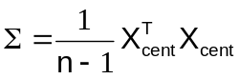,

where is the number of data pairs, which is the same as the number of rows of the matrix . We have seen that in our case . Here is the code:

n <- nrow(X)
n
Sigma <- t(X.cent) %*% X.cent / (n - 1)
Sigma

The function t stands for transpose and %*% is used for matrix multiplication.

We can easily confirm that this is the covariance matrix:

var(X)

Exercise: Provide an interpretation for every element of . Use the elements of to calculate the sample correlation between and .

Note: The matrix 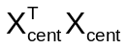 is an example of a sum of squares and products matrix. Can you see why?

Properties of the Covariance Matrix

The matrix has special properties. One of these is that 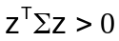 for any vector : for example, taking 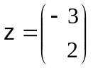 we get:

t(c(-3,2)) %*% Sigma %*% c(-3,2)

which is seen to be positive.

Because of this property we say that is positive definite.

Exercise: Calculate 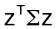 for different values of .

Eigenvalues and Eigenvectors

If you’ve not yet met eigenvalues and eigenvectors, please don’t worry about this section.

Fact: the eigenvalues of a postitive definite matrix are positive.

Exercise: Work out by hand the eigenvalues of .

We can compute eigenvalues in R:

eigen(Sigma)
eigen(Sigma)$values

# Look at the eigenvectors
eigen(Sigma)$vectors

Note that the function eigen produces both eivenvalues and eigenvectors. We can access either using the dollar $.

Exercise: Confirm that the eigenvectors given by R are indeed eigenvectors.

The sum of the diagonal elements of a matrix is called the trace.

Exercise: Calculate by hand the trace of .

Confirm in R:

sum(diag(Sigma))

For the sample covariance matrix the sum of the diagonal elements is just the sum of the sample variances of and . Check this:

var(x) + var(y)

Fact: the sum of the eigenvalues of a matrix equals its trace. Check this:

sum(eigen(Sigma)$values)

Fact: the product of the eigenvalues of a matrix equals its determinant. Check this:

prod(eigen(Sigma)$values)
det(Sigma)

So if any eigenvalue is zero, the determinant will be zero and the matrix will be non-invertible or singular.
Correlation Matrix

We are now going to work out the sample correlation matrix as defined and discussed in lectures. For this we need to create a standardized matrix 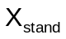 by subtracting the column means and dividing by the column standard deviations:

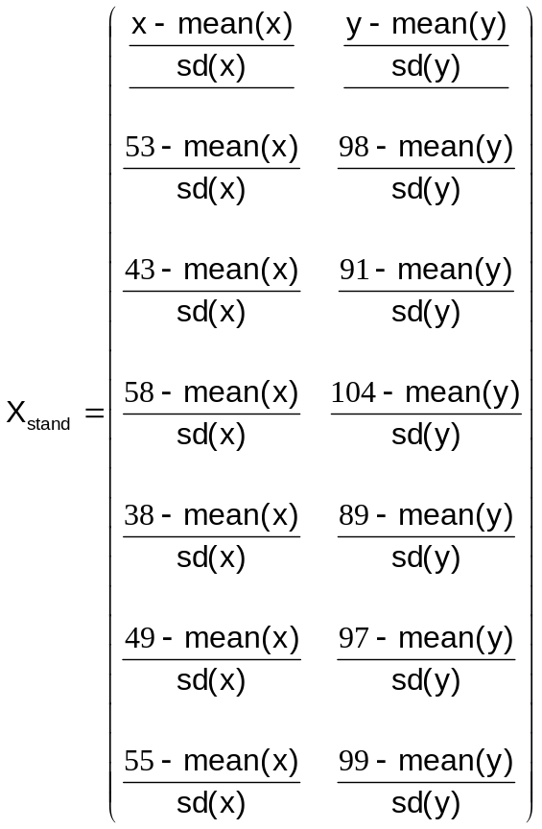

We’ve seen that the columns of this matrix have mean zero and standard deviation one. Let’s calculate 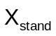 in R:

X.stand <- cbind((x - mean(x))/sd(x) , (y - mean(y))/sd(y) )
#
# Check the column means
#
colMeans(X.stand)
apply(X.stand, 2, mean)
#
# Now check the column standard deviations
#
apply(X.stand, 2, sd)

The sample correlation matrix  can be easily worked out as

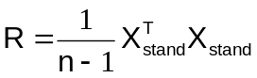:

R <- t(X.stand) %*% X.stand / (n - 1)
R

Confirm that it's the correlation matrix

cor(X)
#
# Work out the sample correlation between x and y
#
cor(x,y)

Exercise: What is the trace of the matrix ? Use R to work out the eigenvalues of and confirm that their sum is equal to the trace. Work out the determinant of and confirm that it’s equal to the product of the eigenvalues. Provide two illustrations that is positive definite. Check that both eigenvalues of are positive.

Transforming Data Variables

Sometimes it’s very important and useful to transform data variables. Say, just for the sake of example, that instead of and , we’re interested in the variables 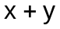 (total) and 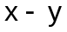 (difference).

Exercise: Compute by hand the new data matrix:

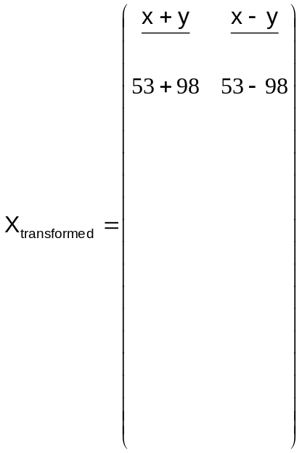

We can perform this transformation in R by matrix multiplication. In particular we can post-multiply the data matrix by the matrix 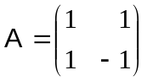. Here is the code to calculate 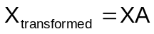:

A <- matrix(c(1,1,1,-1), nrow = 2, byrow = T)
A
#
X.trans <- X %*% A

It turns out that the sample covariance matrix of 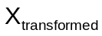 can be found from the covariance matrix of the original data matrix by calculating . Check this:

t(A) %*% Sigma %*% A
#
# Compare with the covariance matrix
# of the transformed data
#
var(X.trans)

A Very Useful ‘Magic’ Matrix

Let’s consider a new matrix , the first column of which is just ones and the second column of which is the data:

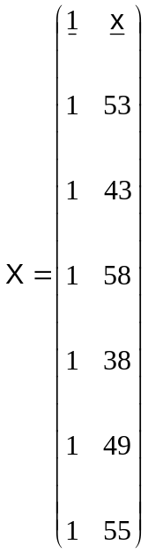

Such a matrix, containing a column of ones and the data, is sometimes referred to as a design matrix. In the case of designed experiments it would contain the information used to design the experiment.

To calculate this new matrix in R, proceed as follows.

ones <- rep(1, times = n)
ones
#
X <- cbind(ones , x)
X

A very interesting matrix, and one that is important in regression analysis, is defined to be

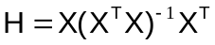.

This matrix is often called the hat matrix.

Exercise: What is the dimension of ?

Let’s define this matrix in R. We can obtain the inverse of a matrix using solve:

# To break down the calculation define Q to be X^T X
#
Q <- t(X) %*% X
#
# Find its determinant to check that it's invertible
#
det(Q)
#
# Perform the calculation
#
H <- X %*% solve(Q) %*% t(X)
H
dim(H)

Note that is a symmetric matrix: 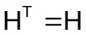:

t(H)
# Difference should be zero
H - t(H)

Let’s enjoy some of the remarkable properties of .

- Its rows and columns sum to one:

rowSums(H)
colSums(H)

- The matrix has no effect when applied to a vector of ones
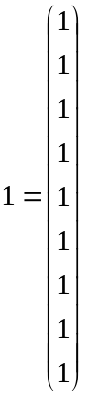: i.e. 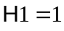:
Try:

H %*% ones

- The matrix has no effect when applied to : i.e. 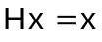

H %*% x
#
# Compare with x
#
x

Taken together these last two properties tell us that

- The matrix has no effect when applied to the matrix : i.e. 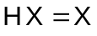

H %*% X
#
# Compare with X
#
X

Exercise: Try to provide a mathematical proof of this last result . Then prove the previous results and .

- Squaring doesn’t change it: 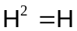:

H %*% H
#
# Compare with H
#
H
# Difference is zero
#
(H %*% H) – H

- In fact this means that any power of is : 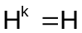 for all 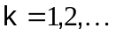. Exercise: Prove this. The matrix is said to be idempotent. For a demonstration that , try 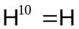:

H %*% H %*% H %*% H %*% H %*% H %*% H %*% H %*% H %*% H

We also say that is a projection matrix into the space spanned by the columns of .

Another Projection Matrix

Another matrix with nice properties is , where here is a 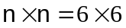 identity matrix. We can define in R as:

I <- diag(n)
I

Exercise: Use R to investigate the following, and then state the properties of :

- What are the row sums of ?
- What are the column sums of ?
- What is 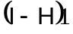?
- What is 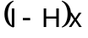?
- What is 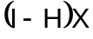?
- What is 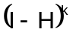?

Try to provide a mathematical proof of the above results.

Linear Regression

The aim of linear regression is to find out about an underlying straight line relationship from data. We are going to use a matrix approach to do this.

Here is a plot of the data that we met above.

The data seem to support an underlying linear relationship and we will use matrices to estimate that relationship.

In particular we will fit the linear model

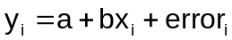,

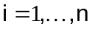, to the above data; recall that here . The value of the intercept and the slope are unknown and have to be estimated (or inferred) from data.

We can represent the above equations

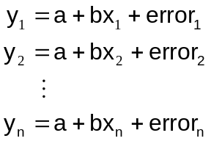

in matrix form as:

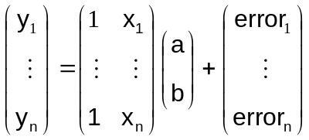

or, using the above vector/matrix notation:

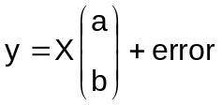
where 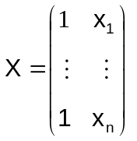 as before.

You will see in detail in Stage 2, or elsewhere, that the estimates and of and can be found by solving the equations

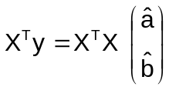,

or, swapping the two sides of the equation,

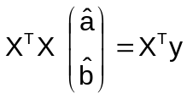

We saw how to solve equations like this in the section on Simultaneous Equations. The solution is

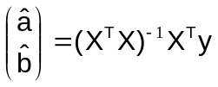.

To calculate these estimates in R try:

# Remember that Q = X^T X has already been defined
#
estimates.ab <- solve(Q) %*% t(X) %*% y
estimates.ab

giving

[,1]
ones 61.4930876
x 0.7062212

This means that 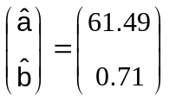, or the intercept is estimated as 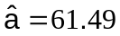 and the slope is estimated as 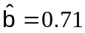.

For the individual elements, do:

# Estimate of intercept
estimates.ab[1,1]
# Estimate of slope
estimates.ab[2,1]

To add the fitted line 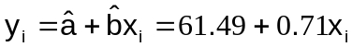 to the graph, just give abline the intercept and slope:

abline(estimates.ab)

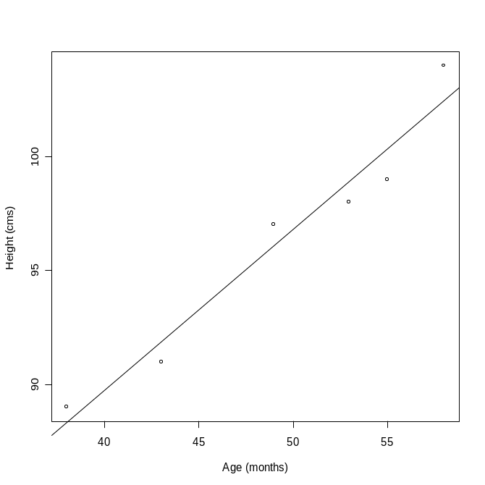

R has its own function to fit a linear model to data, called lm. Here it is in action:

my.lm <- lm(y ~ x)
coefficients(my.lm)
#
# Add a red line to the graph
#
abline(my.lm, col = "red")

The same!!!

Exercise: Let 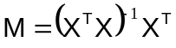. What is the dimension of ? Find a mathematical expression for 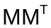? Confirm your expression in R.

Fitted Values

Fitted values are values predicted by the fitted model. Remember that the model can be represented in vector/matrix form as

.

The fitted values are therefore

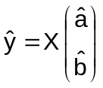.

We’ve seen that

.

Substituting we obtain

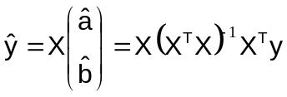.

But the hat matrix , giving us 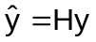.

In summary

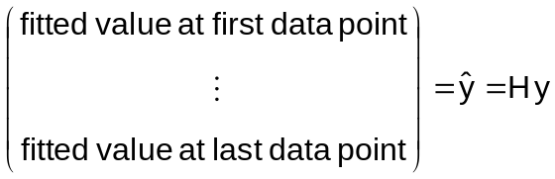.

Note that our good friend the hat matrix appears again!

We will now calculate fitted values in R and compare the results with those provided by the function fitted:

H %*% y
#
# Check:
#
fitted(my.lm)

Residuals

As mentioned in the lecture, the error made at each data point is called a residual:

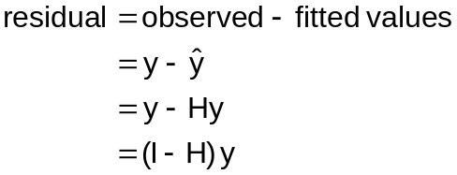

In summary

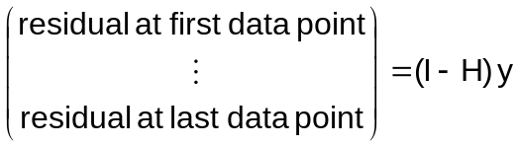

Again, here is the R code, together with a comparison with the output of the function residuals:

I <- diag(n)
(I - H) %*% y
#
# Check:
#
residuals(my.lm)

Exercise: What is the sum of the residuals? Proof?

That’s enough about regression for the moment.

